2200032991

WEEK-4 spring-rest-handson

Spring Core – Load Country from Spring Configuration XML

Output the data format

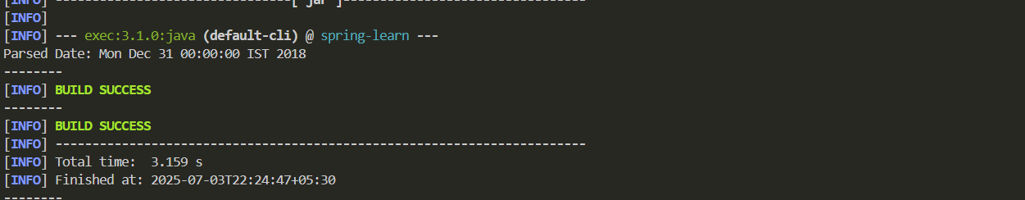

date-format.xml

<?xml version="1.0" encoding="UTF-8"?>

<beans xmlns="http://www.springframework.org/schema/beans"

       xmlns:xsi="http://www.w3.org/2001/XMLSchema-instance"

       xsi:schemaLocation="http://www.springframework.org/schema/beans

       https://www.springframework.org/schema/beans/spring-beans.xsd">

    <bean id="dateFormat" class="java.text.SimpleDateFormat">

        <constructor-arg value="dd/MM/yyyy" />

    </bean>

</beans>

SpringLearnApplication.java

package com.example.springlearn;

import java.text.ParseException;

import java.text.SimpleDateFormat;

import java.util.Date;

import org.springframework.context.ApplicationContext;

import org.springframework.context.support.ClassPathXmlApplicationContext;

public class SpringLearnApplication {

    public static *void* main(String[] *args*) throws ParseException {

        displayDate();

    }

    public static *void* displayDate() throws ParseException {

        ApplicationContext context = new ClassPathXmlApplicationContext("date-format.xml");

        SimpleDateFormat format = context.getBean("dateFormat", SimpleDateFormat.class);

        Date date = format.parse("22/12/2022");

        System.out.println("Parsed Date: " + date);

    }

}